Eldion Vincent H. Bartolo 2010-28167

ES 204 Machine Problem

**Problem 1**

*Solution:*

First the first derivative of the boundary condition is approximated using 3 point finite difference method,

$$ψ^{'}\left(0\right)=0 =\left(\frac{1}{2h}\right)*\left(-3ψ_{0}+4ψ_{1}-ψ_{2}\right)$$

$$ψ_{0}=\left(\frac{1}{3}\right)*\left(4ψ_{1}-ψ_{2}\right)$$

Nothing follows. I really don’t have an idea how to solve this. ;(

*Summary of Results:*

NONE

*Problems Encountered:*

I think that the problem overall is time consuming and it is the hardest problem in the whole MP. I don’t know how to get the differential equation and put it to an integral function.

*References:*

NONE

**Problem 2**

*Solution:*

First two ODE-IVPs are created to simplify the problem

1. y’ = v, with B.C. of y(0) = 2
2. v’ = y’’ = 25(1-y2)*v – y, with B.C. of v(0) = 0

The values for yi ‘s are solved first followed by vi w/c is dependent on the most recent value of yi.

Since the ODE is stiff, a couple of modification is done in the predictor and corrector of implicit heun. The program created can’t predict a correct solution even if there are modifications, so I used a smaller step size of 0.005

*Summary of Results:*

Using a finer step size of 0.005. The figure below shows the solution of the ODE using implicit heun.

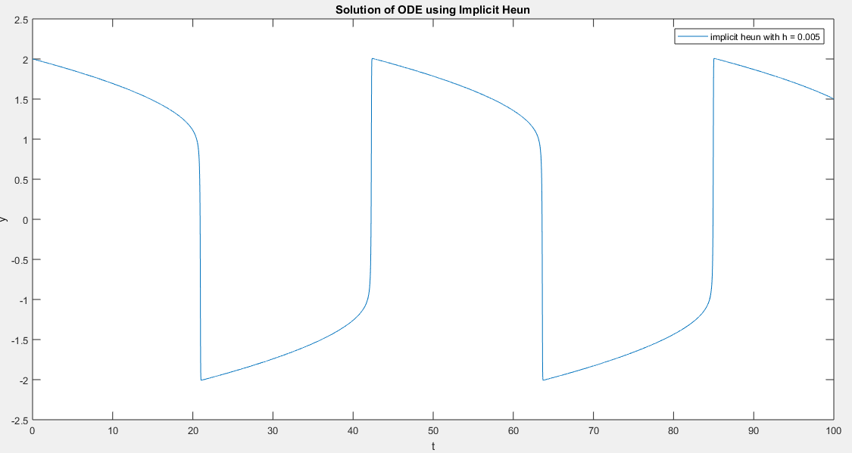

*Problems Encountered:*

The most time consuming would be creation of a program that solves the 2nd order ODE using implicit heun. The hardest part would be how to minimize the stiffness of the problem since I can’ t solve it using the defined step size. The problems encountered would be how separate the problem into 2 ODES. I consulted a lot of reading materials and matlab codes in the internet, please see references given below.

*References:*

1. http://www.math.mcgill.ca/gantumur/math579w10/?Matlab_files
2. https://math.oregonstate.edu/home/programs/undergrad/CalculusQuestStudyGuides/ode/second/so_num/so_num.html

**Problem 3**

*Solution:*

The Poisson PDE can be discretized with the following equations.

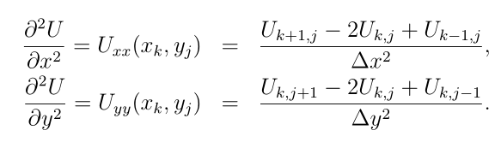

Equation 1

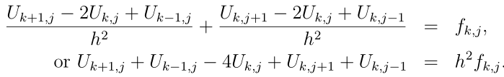

Equation 2

For m=3 interior points this can further simplified to equation 3:

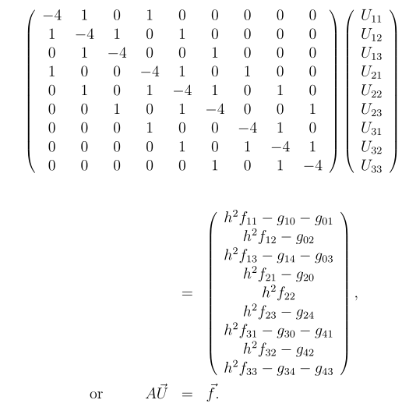

Equation 3

Since the boundary conditions( g’s) are not easily accessible. The Neumann boundary conditions are simplified using forward and backward finite difference approximation of the first derivative.

Thus the following equations can be derived:

1. u1j – u0j = 5h(u0j - 25)
2. um+1,j – umj = 5h(25-um+1,j)
3. ui1-ui0 = 5h(ui0-25)
4. ui,m+1-ui,m=5h(25-ui,m+1)

where h = dx = dy.

Through manipulation the simplified equations for the boundary conditions are described below.

1. u0j = g0j = 75h/(5h+1) + u1j /(5h+1)
2. um+1,j = gm+1,j = 75h/(5h+1) + umj /(5h+1)
3. ui0 = gi0 = 75h/(5h+1) + ui1 /(5h+1)
4. ui,m+1 = g i,m+1 = 75h/(5h+1) + u im /(5h+1)

The derived B.C.’s are then inputted both in the **f** and **A** matrices shown in equation 3.

*Summary of Results:*

I used the .m file of my reference(1) and edited the parameters accordingly, especially the boundary conditions and other function evaluations. The contour plot is shown below:

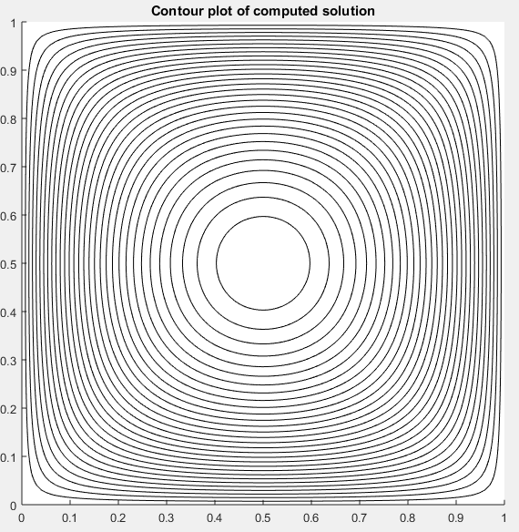

*Problems Encountered:*

The most time consuming would be creation the boundary conditions to and how to integrate it to the poisson equations. The hardest to understand is the boundary conditions because it is not in Dirichlet form. Actually there are no problems in coding because I borrowed the code from my reference.. I consulted a lot of reading materials and matlab codes in the internet, please see references given below.

*References:*

1. <https://faculty.washington.edu/rjl/fdmbook/matlab/poisson.m>
2. Numerical solution of partial differential equations - UQ eSpace

**Problem 4**

*Solution:*

First the partial derivatives with respect to x is discretize:

$$\frac{du_{i}}{dt}=0.05\left(\frac{u_{i+1}-u_{i}+u_{i-1}}{h^{2}}\right)-u_{i}\left(\frac{u_{i+1}-u_{i-1}}{2h}\right)$$

This results to a system of nonlinear ODEs.

Then using RK45 the system of ODEs is to be solved with the appropriate initial conditions..

*Summary of Results:*

The initial condition at t=0 is given below:

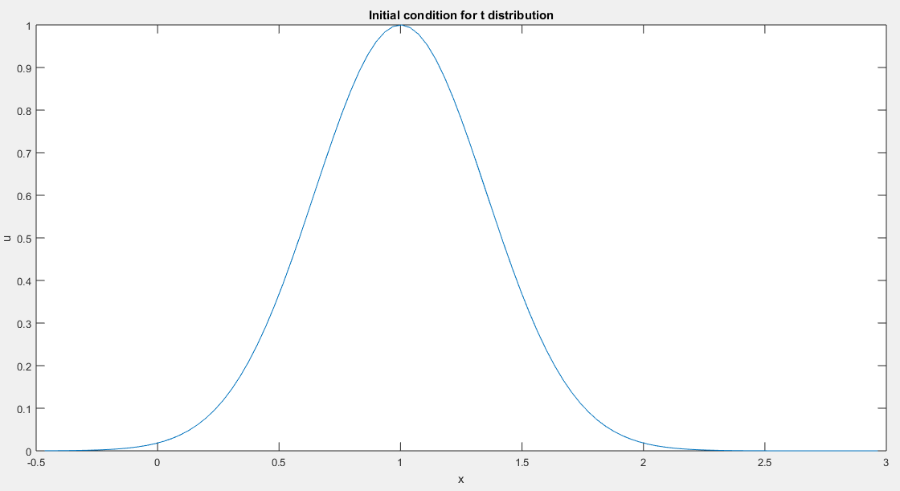

*Problems Encountered:*

The most time consuming would be how to solve a system of nonlinear ODES using RK45.. The hardest to understand is system of ODEs. I had difficulty in solving system of nonlinear ODEs. I consulted a lot of reading materials and matlab codes in the internet, please see references given below.

*References:*

1. Numerical solution of partial differential equations - UQ eSpace